MOTORMAX ESCALA 1/24 (APROX 18 CM DE LARGO)
PICK-UP FORD 1940 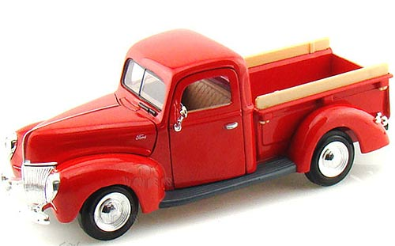

PICK-UP FORD F-100 1956 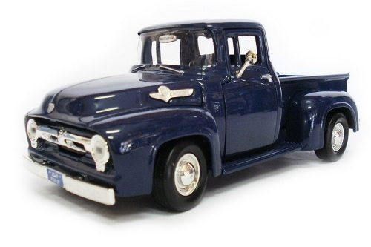
PICK-UP FORD 1937 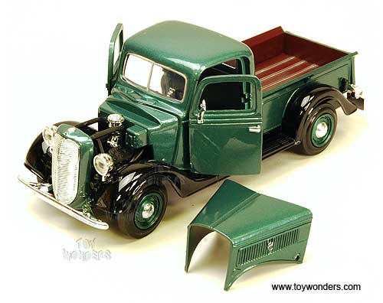
PICK-UP FORD F-100 1969 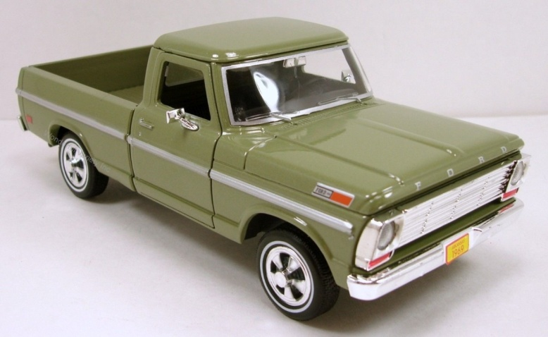
PICK-UP PLYMOUTH 1941 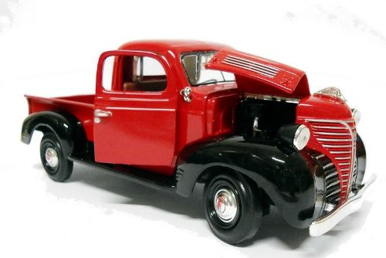
PICK-UP CHEVROLET APACHE 1958 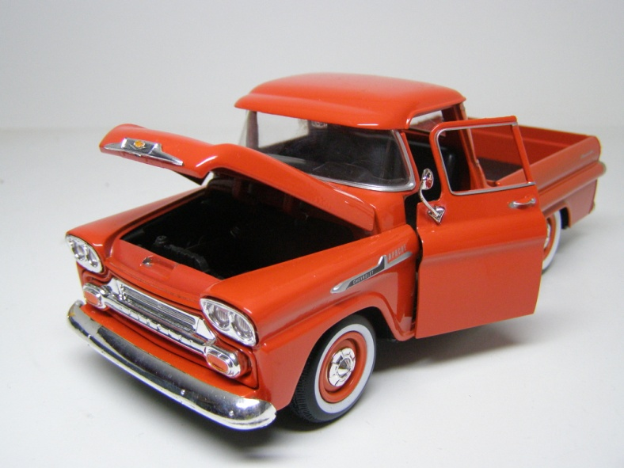
PICK-UP CHEVROLET FLEET C10 -1966 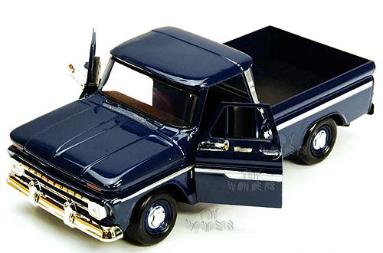
PICK-UP STEPSIDE 5100 -1955 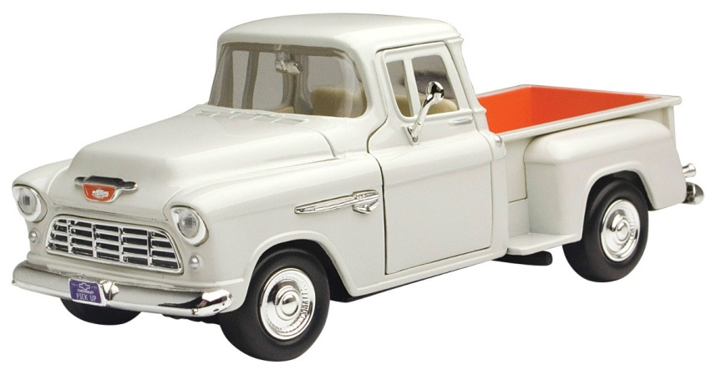
FORD MUSTANG BOSS 429 -1970 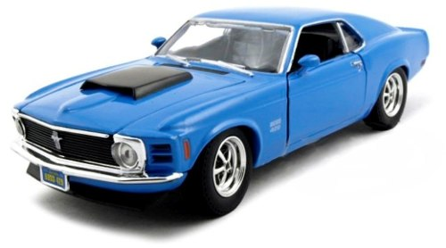
CHEVROLET IMPALA -1958 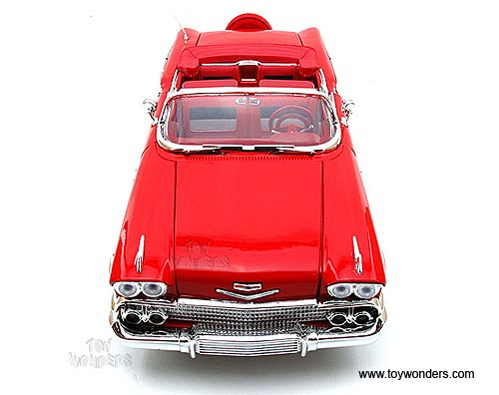
CHEVROLET CAMARO -1967 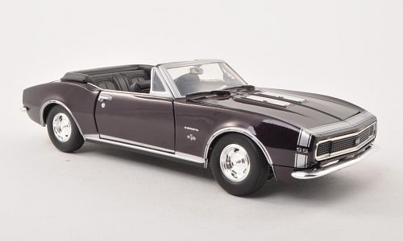
CHEVROLET BEL AIR -1950 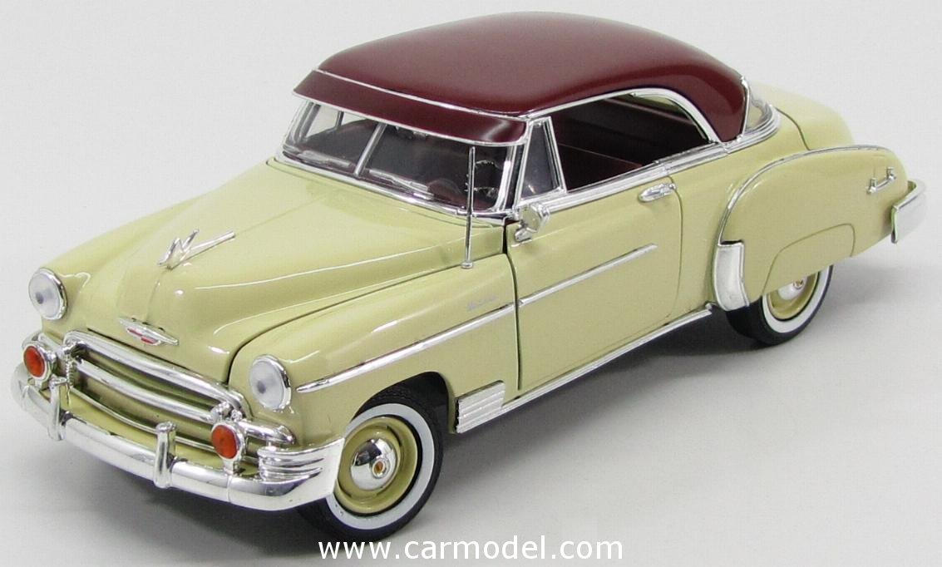
CHEVROLET BEL AIR -1957 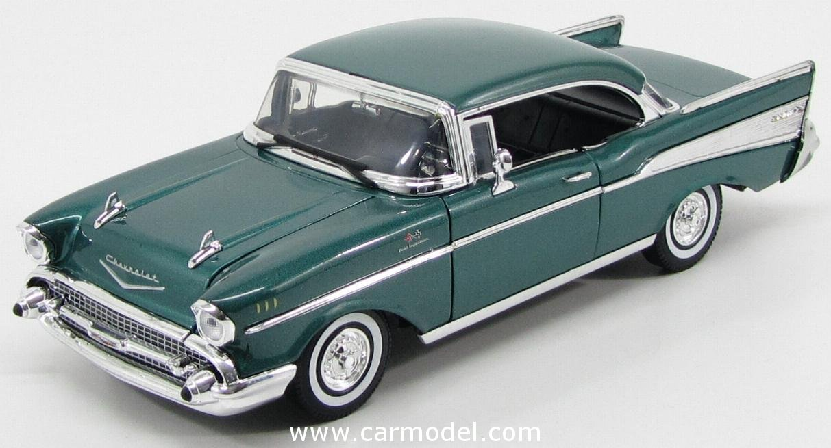
CHEVROLET AEROSEDAN FLEET -1948 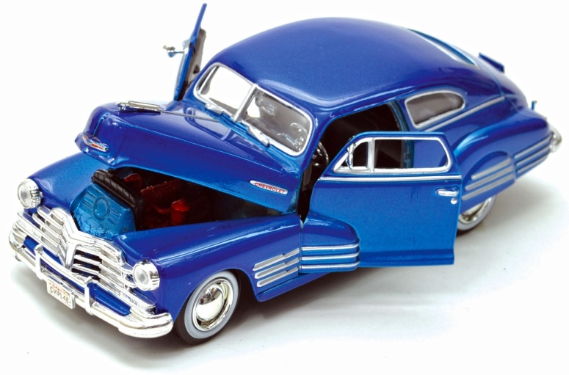
CHEVROLET BEL AIR -1955 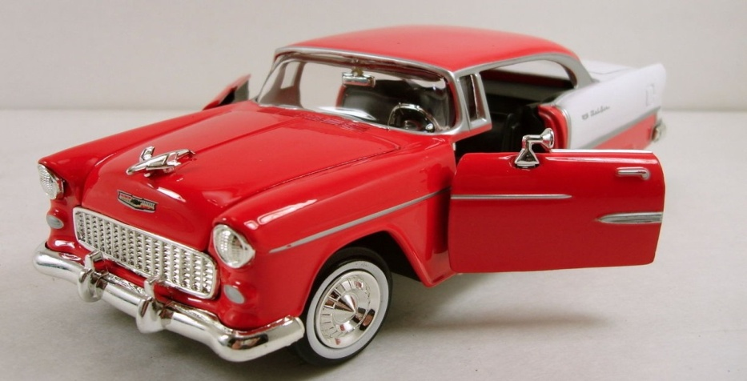
FORD THUNDERBIRD -1956 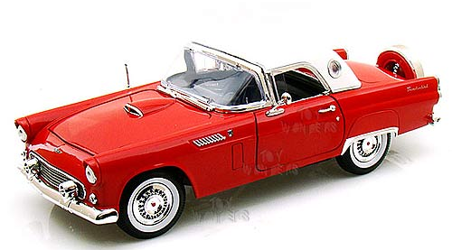
FORD COUPE -1949 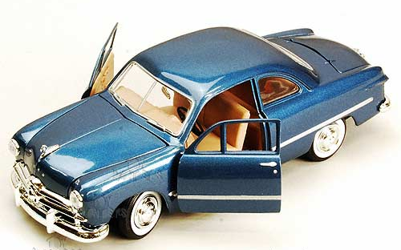

FORD MUSTANG SPORTSROOF 1971 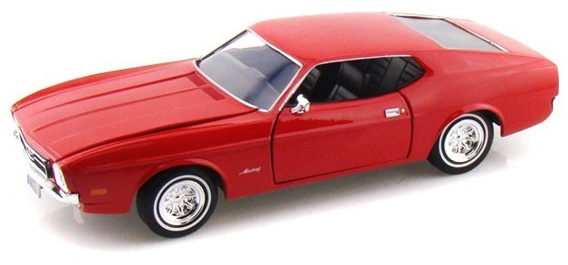
FORD MUSTANG -1964 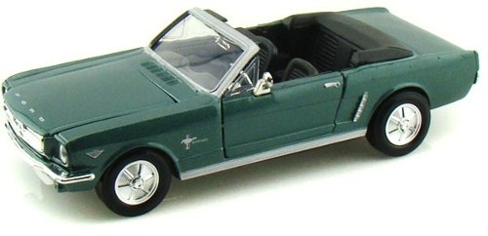
PONTIAL GTO JUDGE -1969 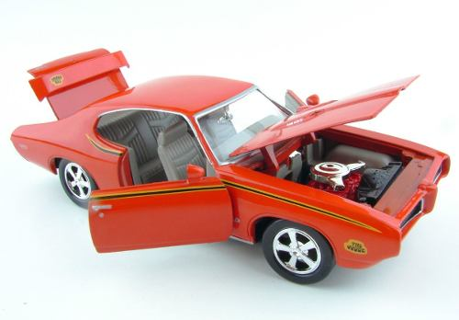
DODGE CORONET SUPER BEE -1969 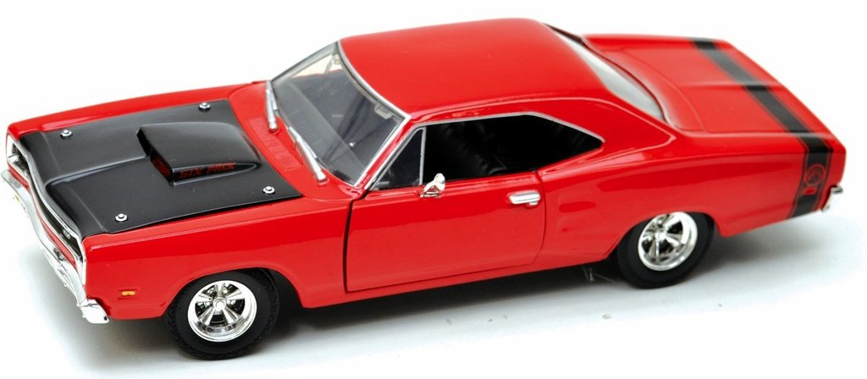
MERCURY COUPE -1949 